**ASSIGNMENT 1**

**PROJECT PROPOSAL**

**STUDENT DIARY**

**PRODUCT SUMMARY**

The purpose of this website is a diary for students. The diary will allow for a user to track their studies, write down notes for any study (seminars/practicals/individual learning), and mood tracking.

Users will have access to their own calendar, where they can add and visualise any upcoming important dates and will receive a notification a week ahead of the event. The website will also allow for a user to create notes, giving the note a title and be able to add any information about their studies in the body. Lastly, every time the user loges into the website, they will be asked their mood on a scale of “good and bad” and receive a quote, based upon how they are feeling that day.

**ASSET LISTS**

|  |  |
| --- | --- |
| Asset | how it will be used |
| index.html | This will act as a home page for my website, where user will be able to navigate to all the different functionalist on the website. The index will act as a foundation for all the other pages. |
| calander.html | A page where a user will be able to input and view all important upcoming dates for their studies. |
| allnotes.html | This page will display all the previous notes made by the student |
| newnote.html | The new note page will allow for a student to create a new note, giving it a title and body |
| styles.css | Responsible for the structure and styling of the website |
| images.png | Responsible for any images that will be added to the website. |
| Quote.vue | Has the responsibly of obtaining a quote, based off the mood response |
| mood.vue | Will ask the student their mood when they log into the website |
| register.vue | Single file registration component where a user will be able to register for the website |
| login.vue | This component is responsible for allowing a user to log into their personal account |
| signout.vue | This component is responsible for logging a user out of their account so the next time they access the website, they must re-enter their credentials next time they access the website |
| notepad.vue | Responsible for a rending a text input for a title of the note, and a text input for a user to enter their notes. This will also include a publish button, so the user can view the note later. |
| notehistory.vue | Is responsible for showing all previous notes a user has publish. This will show all previous notes, listed displaying only their title |
| calendar.vue | Responsible for allowing students to enter specific dates, and giving reminders to students 7 days ahead of the due date set |
| search.vue | A user be able to type into a text box the title of a note, eliminating the need to scroll through their various notes. |

**product purpose**

**Target Audience**

The intended audience of the study diary is students. The diary will allow students to plan out all their current units and track any upcoming important date. Calendar tracking for students is very important, as it is a visual representation of what is going on in their (usually stressful) life and allows for a student to see how long until each task is due and will also be able to visualise things such as work.

Creating a space where students can both have a calendar and take notes all in one will improve their overall productivity, as everything they need is on the one website and they don’t need to keep switching between resources and potentially getting distracted or wasting time.

Mental health should be something everyone takes into consideration. With the stress students can face sometimes, a mood tracker helps students track their mental health over their time of study, and can review how they have been feeling, and a motivation quote will help them to either change their mood if they are angry, so they can destress and focus on study, or if they are in a good mood, give a quote based around that mood to keep the positivity in the student.

**Creativity justification**

The website demonstrates creativity in its design, as its user-friendly, and will allow the user to have a seamless experience on any of their devices. The user-friendly experience allows for new users to be able to join and practically pick up all functionally straight away.

The website demonstrates a something new and exciting as there is currently no other resource with an ‘all-in-one’ system for students where they can track important dates, take notes, and track their mental health.

**complex components**

**Notepad (notepad.vue)**

Notepad will allow for the user to set a title for their note and create a body paragraph of all their study notes. Users will have full functionality of design elements such as font size, colour, and bold text. The user will be able to use the toolbar to easily select the design element they would like to use and apply it to the body section of their notepad

**Calendar (calendar.vue)**

Calendar will allow for students to plan all their upcoming events, by adding an event with a title and short description into a date on the calendar. The student will be able to view the calendar at any time and hovering over an event on the calendar will display the title, and the contents (if any) of the short description. The user will be able to set reminders, so that leading up to the event, they are sent a reminder in their notifications inbox that the event is happening in X amount of days

**Mood (mood.vue)**

Mood will be responsible for prompting a user with either a sad or happy face when they first login to the site. Based on the response given to the user, it will display a randomly generated message on the side of the screen. Their response will also be added to their calendar so that the user will be able to look back at past dates and track their mood over any given date

**user stories**

|  |  |
| --- | --- |
| statement | Acceptance criteria |
| As a user, I want the functionality to be able to write down my notes | 1. user must be able to write text into a text box  2. user must be able to confirm when they are finished writing a note |
| As a user, I want the functionality of saving notes | 1. user must be able to save the note  2. user must be able to come back to the note after it has been saved and finished |
| as a user, I want the functionality of a creating a title for my notes | 1. the user must be able to give the note a title  2. the user must be able to save the note with its title |
| As a user, I want the functionality to be able to edit notes | 1. user must be able to edit the title and or content of the note  2. user must be able to save the updated version of the note |
| as a user, I want the functionality of adding all my events into a calendar | 1. user must have the ability to add important dates into their calendar  2. user must have the ability to be able to save the event they have added to the calendar  3. user must be able to view the calendar with the event displayed on the calendar  4. user must be able to update the calendar at any time to update/delete and event. |
| As a user, I want the functionality to be able rate and review my emotions | 1. the user must be prompt with a ‘happy’ or ‘unhappy’ question  2. the user must receive a randomly generated quote, based on how they are feeling that day  3. the user must be able to reflect on their past emotions |
| As a user, I want the functionality to be able to stay logged in | 1. the user might have the ability to create an account  2. the user must have the ability to log into their account  3. they user must have the ability to ‘stay signed in’ or log out when they close the website |
| As a user, I want the functionality to be able to use the website from any device | 1. the user must have the ability to access the website from any device. |

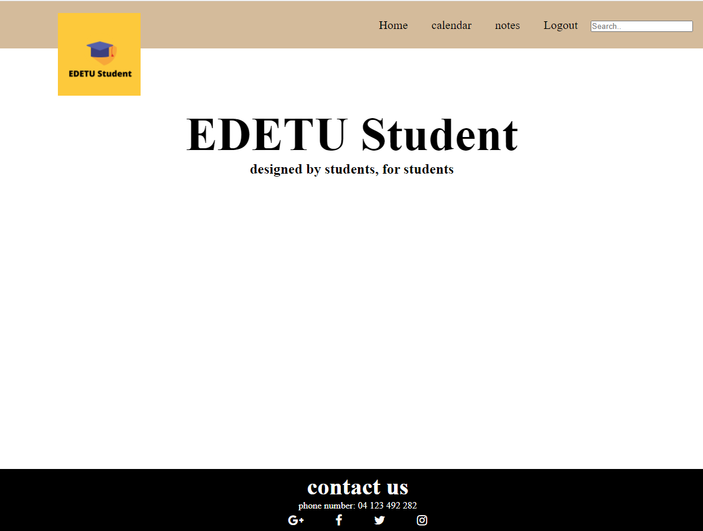**UX/UI designs**

The colour scheme I have chosen to go with is as follows:

|  |  |
| --- | --- |
|  | RGB (173, 111, 31) |
|  | RGB (256, 204, 60) |
|  | RGB (2,2,2) |
|  | RGB (255, 255, 255) |

**Justification of style**

The logo of my website is the same colour I have used throughout my project proposal (RBG 256, 204, 60), with the subtle hints of yellow under each heading throughout the proposal. I have chosen to use a darker yellow, which is a beige colour as my header background, as it’s a neutral colour, which has proven to evoke feelings of happiness, which overall will help students with the completion of their work and allow for students to have a more enjoyable time whilst visiting the website for their studies. The choice of using solid white background is because its easy to match any colour with white, it allows for multiple colours to be implemented later when all other pages have been created. Lastly, the use of a black footer is because the footer will always be seen last. It sits at the bottom and is easy for the student to recognise where the page ends. The black and white contrast also makes it easy for students to be able to find all contact information for phone numbers and social medias.

**SYSTEM SUMMARY**

**Functionality**

* Authentication: the ability for a user to log in/create an account
* Rate emotion: the user will be prompt with a question on their current emotions
* Calendar: the user will be able to view a calendar and add new events to it. The calendar will also track the user’s emotion by adding how they felt that day to the calendar
* Notes: the user will be able to create new notes and give the note a title. The user will also be able to review the note and edit/delete it
* View all notes: user can view all notes as per the title of the note in a list
* Edit notes: the user will be able to review their notes, and be able to make changes such as changing the title and adding and deleting contents of the node
* Search: user will be able to type the title of a note into a search bar and it will return the note they are looking for

**Development schedule**

The picture below is the timeline I have set for each task to be completed.

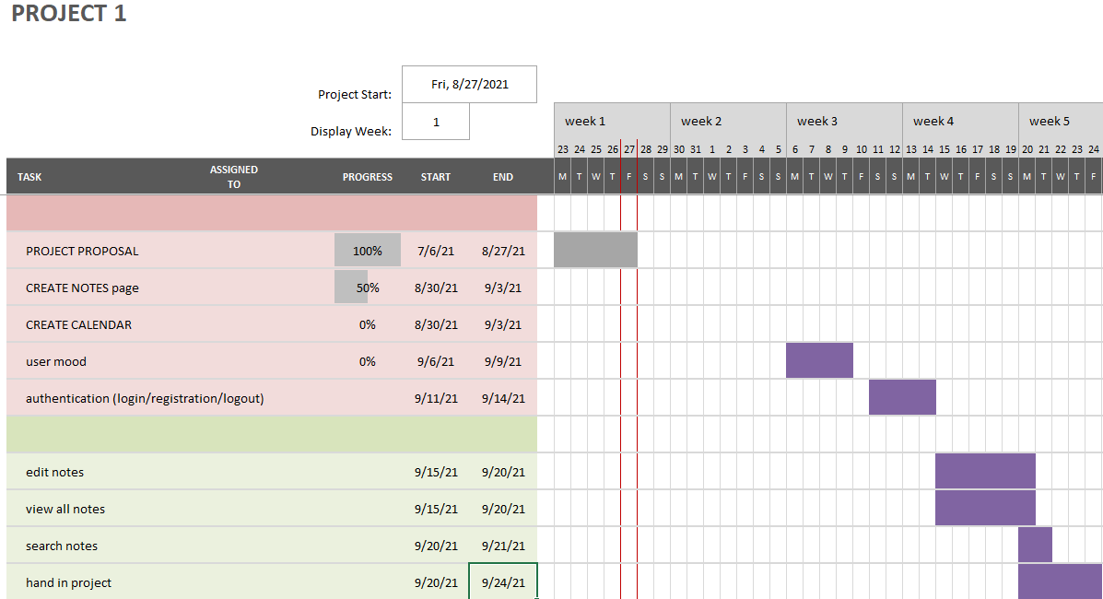

**Feasibility**

There will be lots of tasks to complete to have a finished website, and if I am able to complete 2-3 tasks per week, I will be able to have added all the content to my website and have all the intended functions integrated and working as intended. Although I will encounter setbacks due to issues out of my control, I have enabled my timeline to be able to adapt to any setbacks and makeup any lost time.